Ancient World History Pictures
Picture collage of places we have visited in Ancient World History.
Egypt
Old Kingdom (2575-2150 BC) - Dynasties IV-VIII
The fourth dynasty begins and the Great Pyramids of Giza and the Sphinx are built. This is often called the Age of the Pyramids. The fourth dynasty is a time of peace and also a time when the sun god Re became prominent in the Egyptian religion.
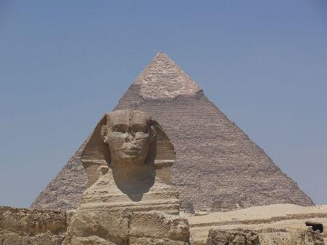
New Kingdom (1520-1075 BC) Dynasties XVIII-XX
The New Kingdom is the time of greatest prosperity for the Ancient Egyptian civilization. During this time the Pharaohs conquer the most lands and the Egyptian Empire reaches its peak.

Ancient Egypt Pharaohs
Tutankhamun - Often called King Tut today, Tutankhamun is largely famous today because much of his tomb remained intact and we have one of the greatest Egyptian treasures from his rule. He became Pharaoh at the age of 9. He tried to bring back the gods that his father had banished. | 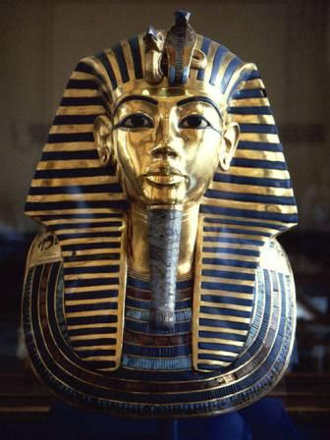
Hatshepsut - A lady Pharaoh, Hatshepsut was originally regent for her son, but she took on the power of Pharaoh. She also dressed like the Pharaoh to reinforce her power including the crown and ceremonial beard. Many consider her to be not only the greatest woman Pharaoh, but one of the greatest Pharaohs in the history of Egypt.
Ramses II - Often called Ramses the Great, he ruled Egypt for 67 years. He is famous today because he built more statues and monuments than any other Pharaoh. 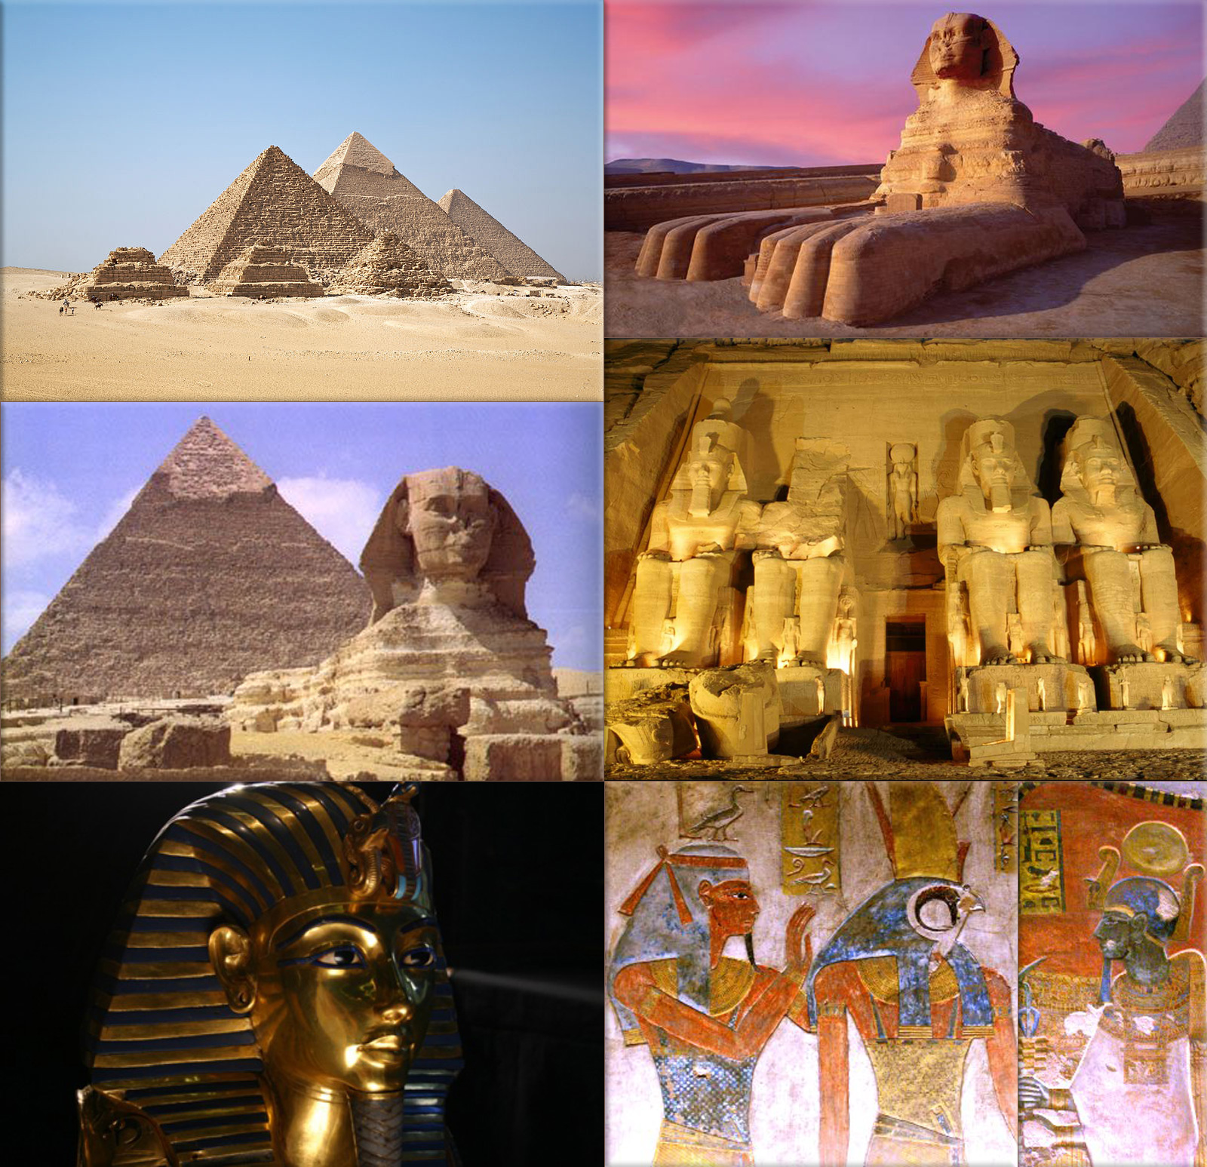

Cleopatra VII - Cleopatra VII is often considered the last Pharaoh of Egypt. She maintained power by making alliances with famous Romans such as Julius Caesar and Mark Antony.

Ancient Israel
Jews believe they are descended from Isaac, who, as the legitimate son of Abraham, was the intended inheritor of God's promised land. Muslims believe they are descended from Ishmael, Abraham's first-born. They say Hagar was Abraham's second wife and believe their claims to the holy land are as valid as those of the Jews.
Abraham has become revered by three religions. In the Christian New Testament, Abraham is called "the ancestor of all who believe." The Koran mentions Abraham more often than the prophet Mohammed, who is believed by Muslims to have been a direct descendant of Abraham. Jews see Abraham as the first person to recognize their God.

THE EXODUS
Famine drove the Israelites from Canaan to Egypt and then, as recounted in the book of Exodus, Moses led the Israelites out of Egypt and back to conquer Canaan around 1200 B.C.E. Until about 721 B.C.E., the Israelites ruled Canaan, calling it Israel in the north and Judea in the south, where they built their first temple in Jerusalem.

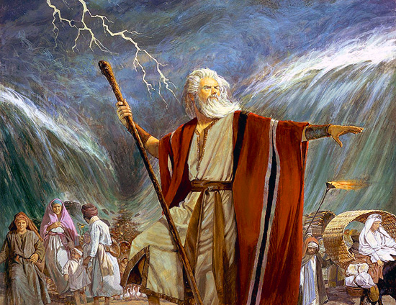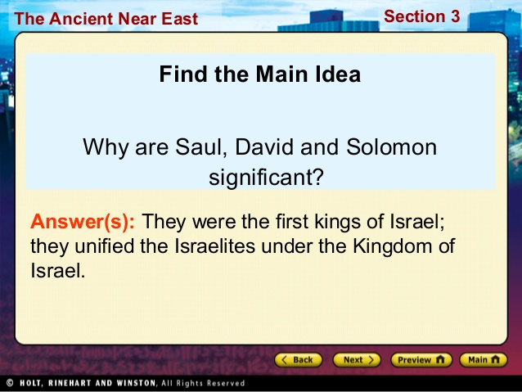

Ancient Persia
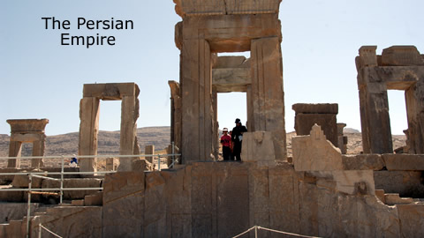
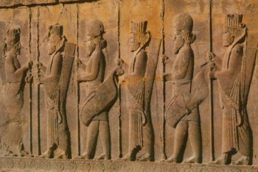
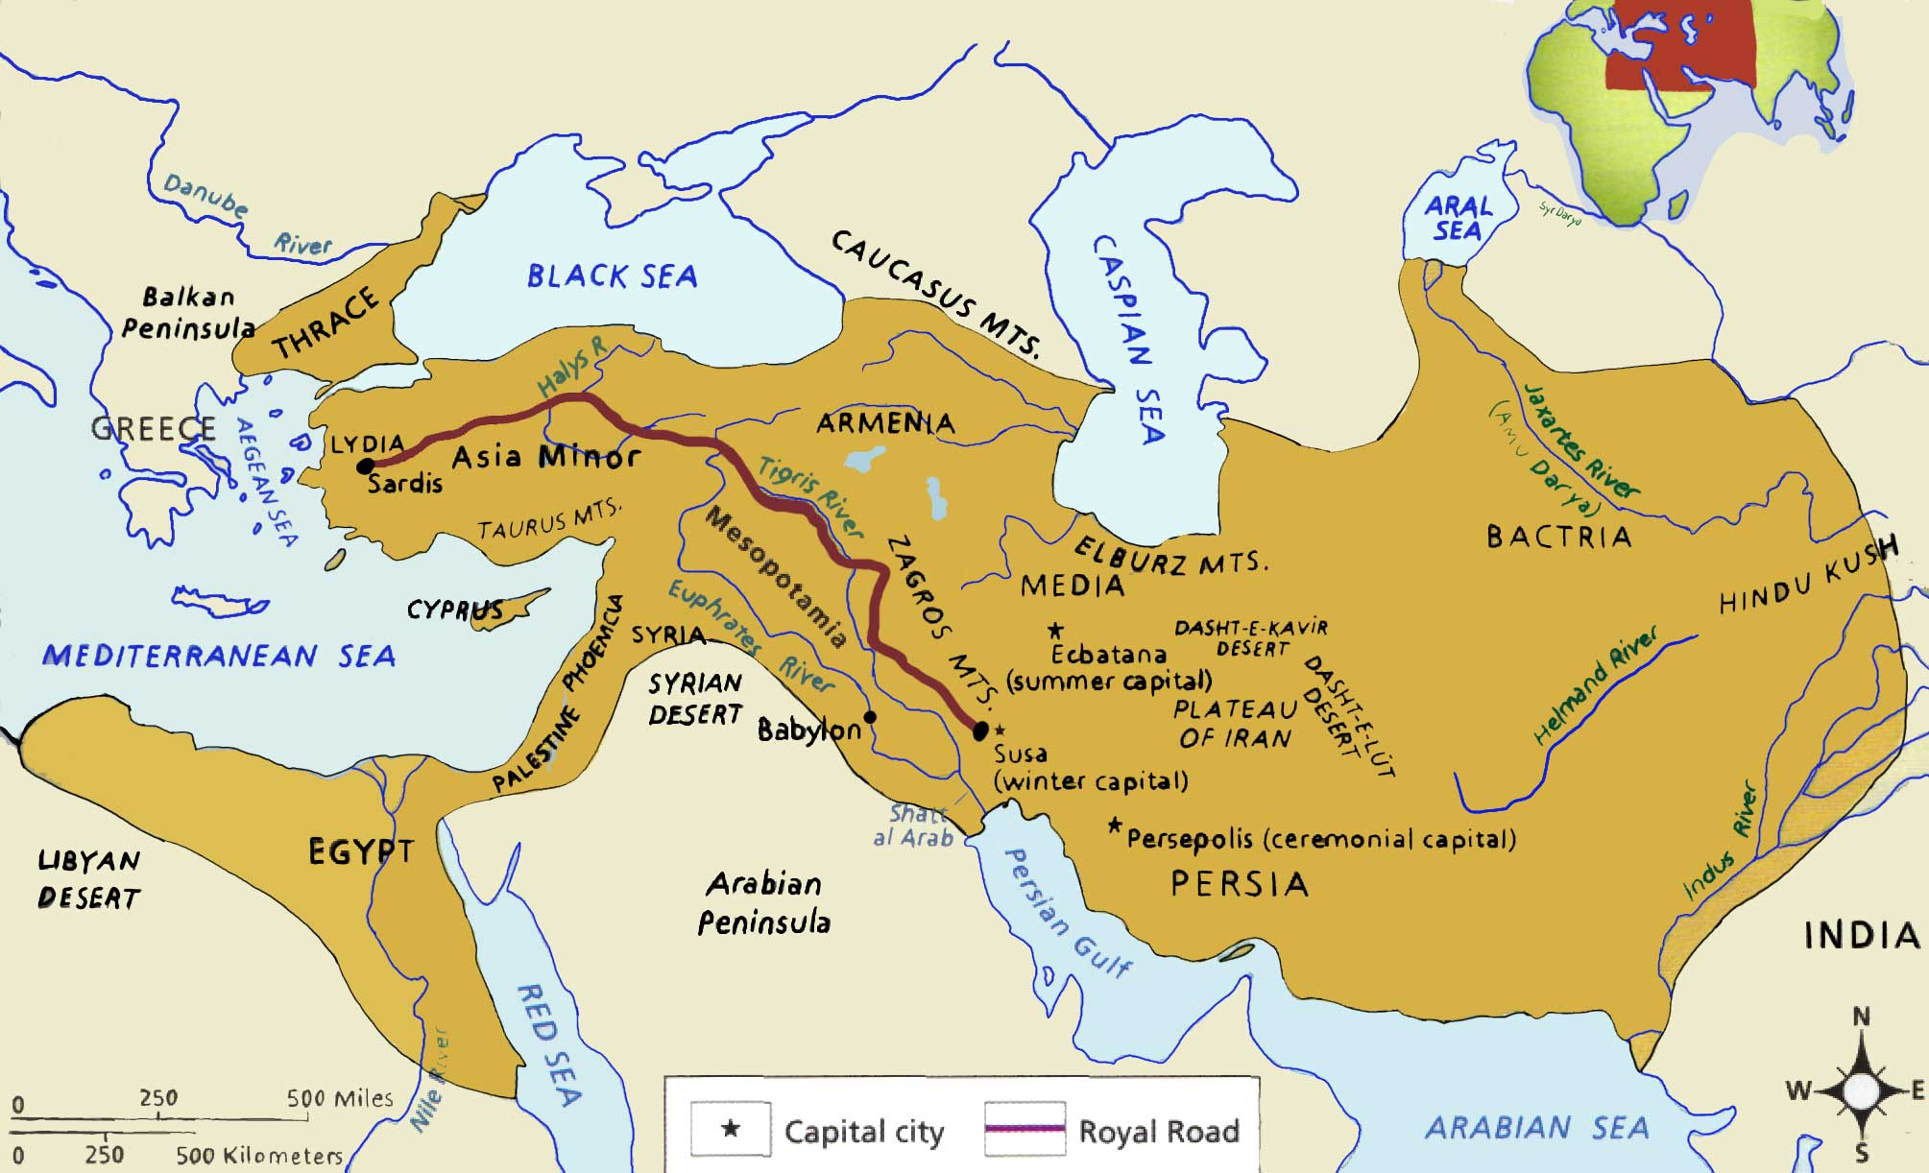
Hammurabi’s Code
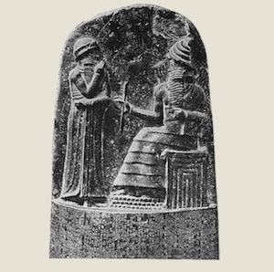
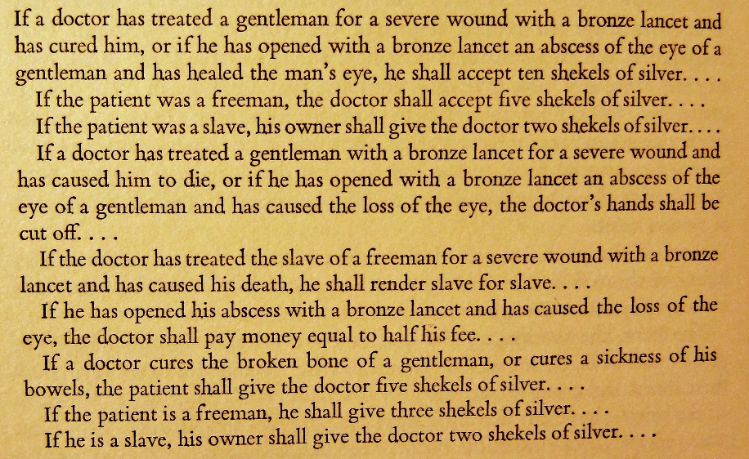
Ancient Mesopotamia
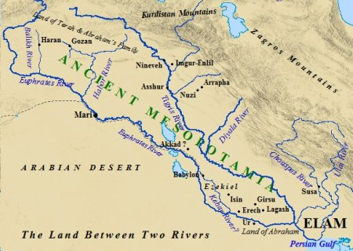
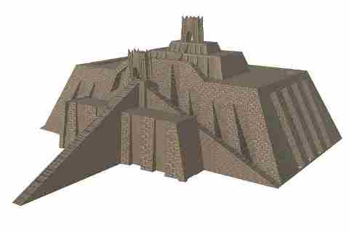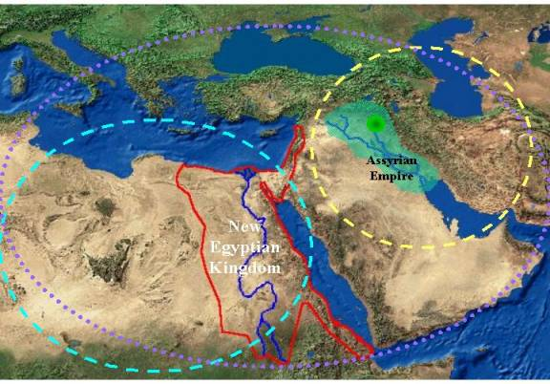

Ancient China
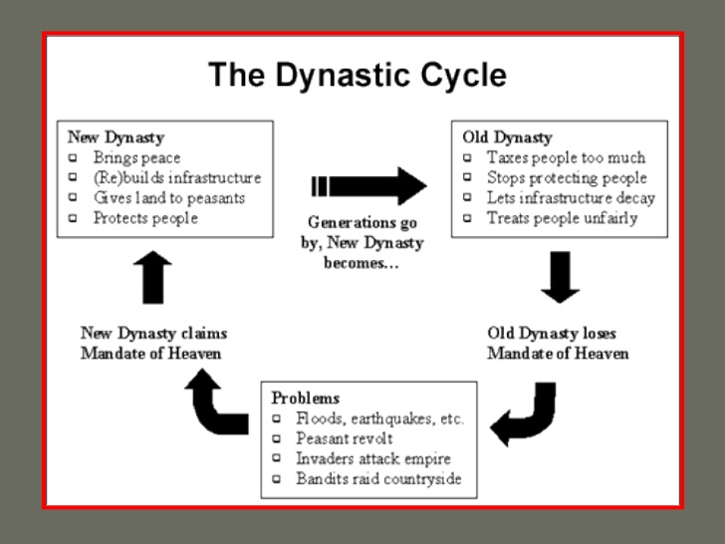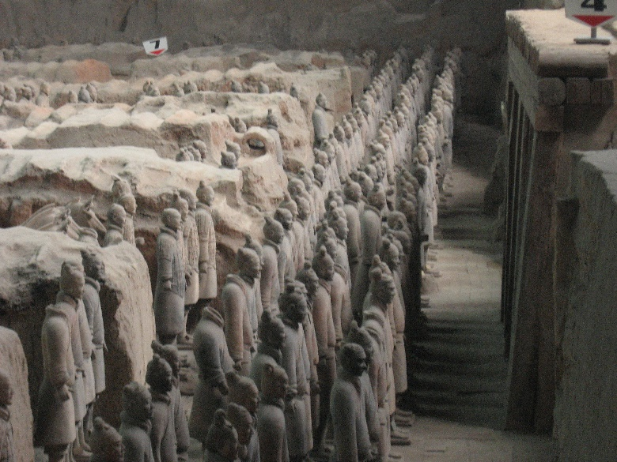

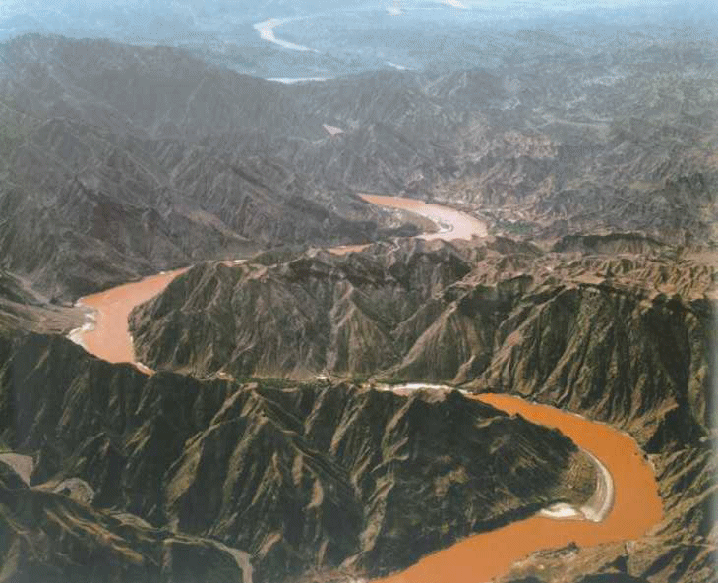
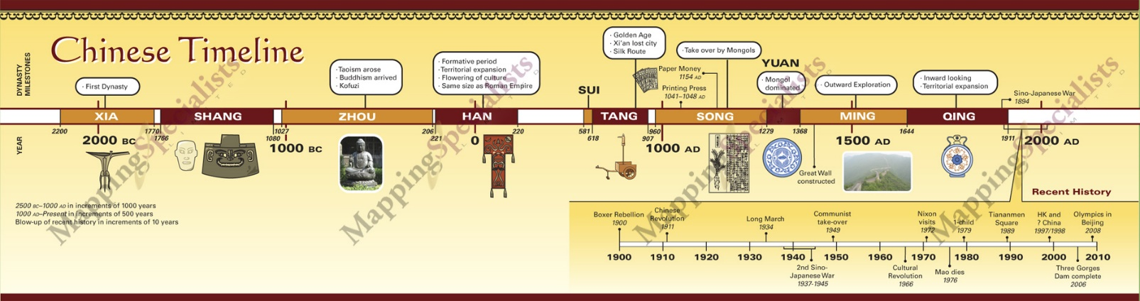

Ancient India
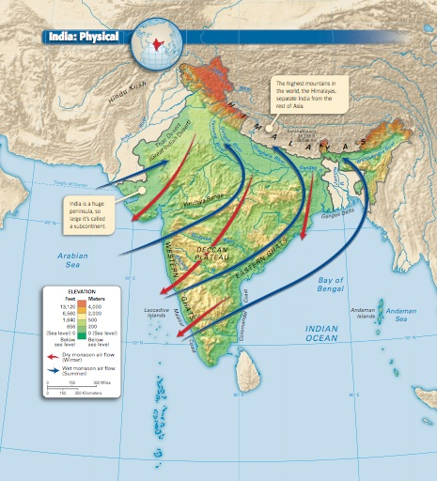
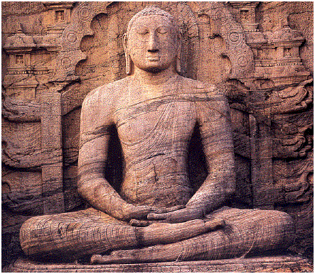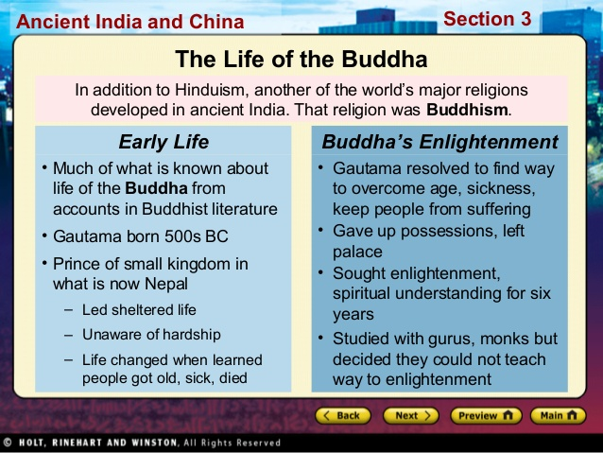
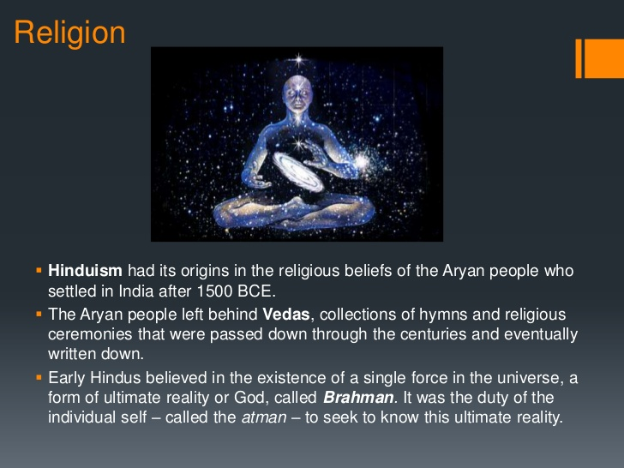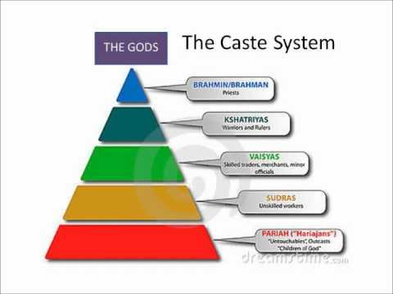
Ancient Greece
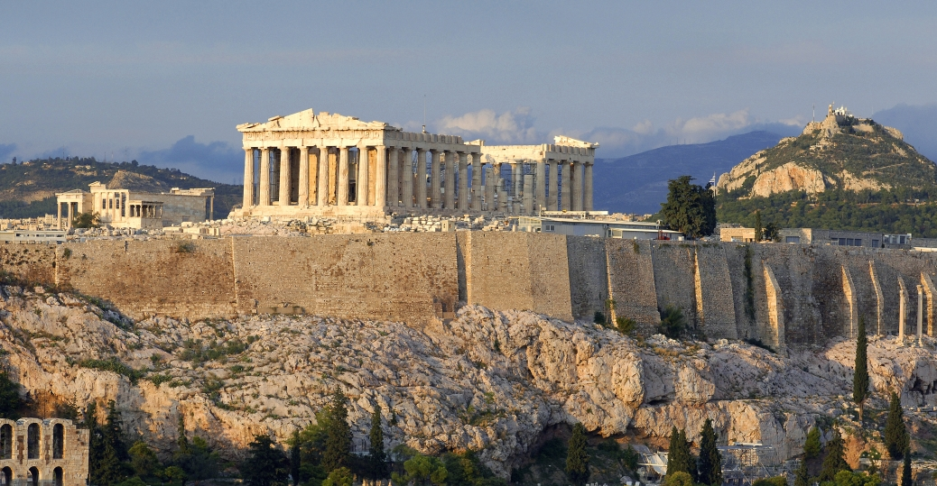
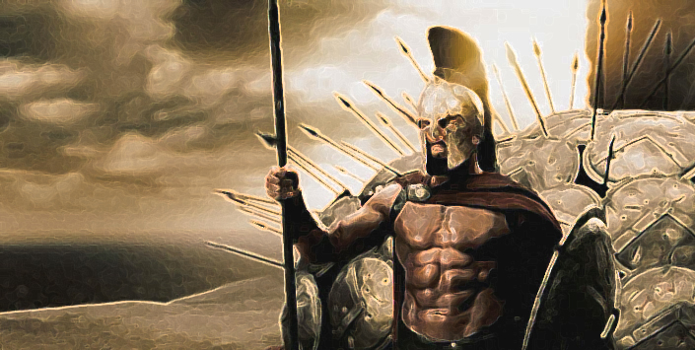
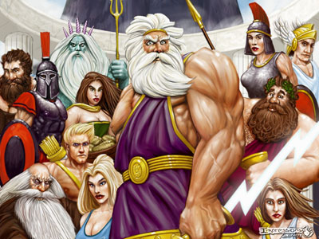

Alexander the Great
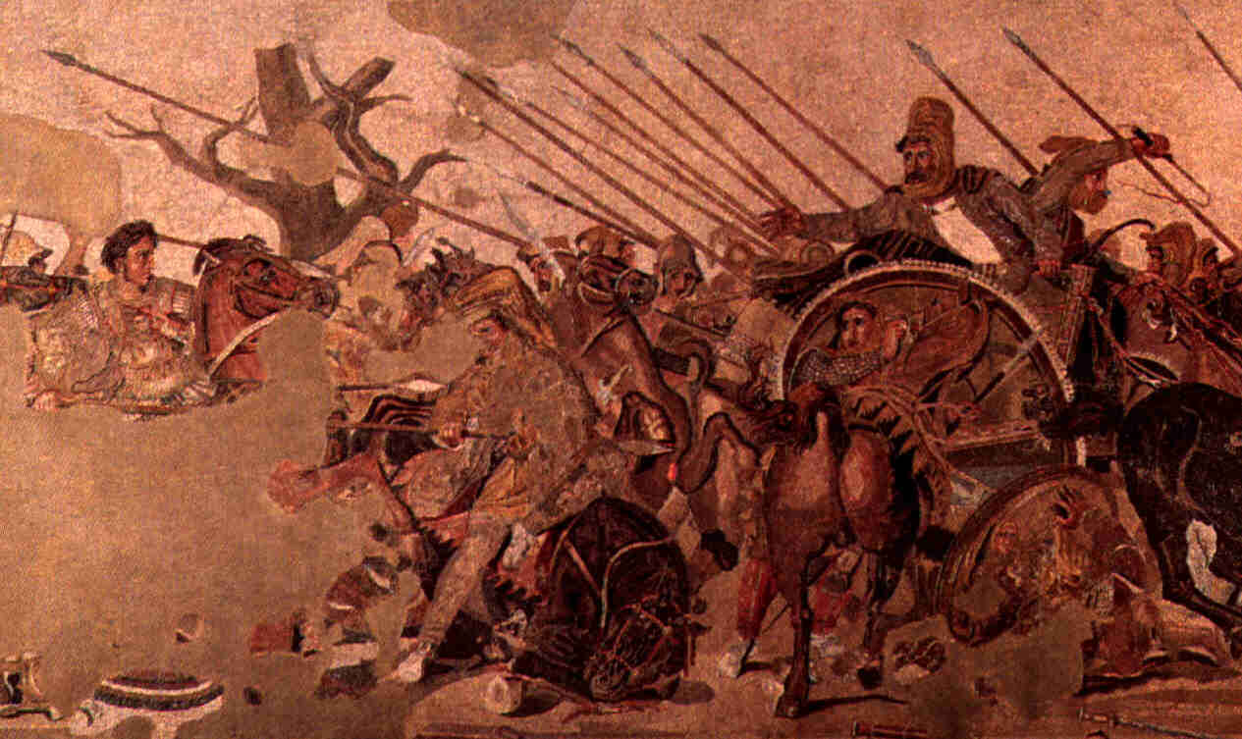
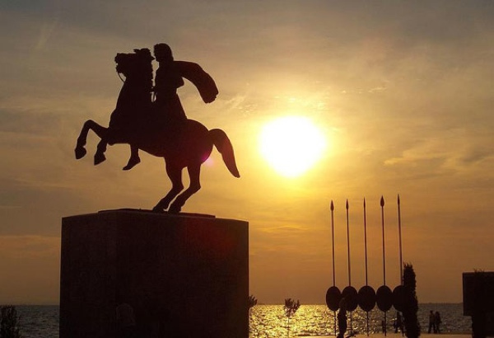

Ancient Rome
